Amendment History:


TRADE BANK OF IRAQ
COLLATERAL
Functional Specification Document

Version | Date | Author / Changed By | Status | Change Description
1.0 | 05-Jan-2022 | Nauman Hussain | Initial

Table of Contents
1. Background 3
1.1 Introduction 4
1.2 Reference Documents 4
2. Acronyms 4
3. Functional Overview 4
4. Existing Functionality 5
4.1.1 Existing Workflow 5
5. Workflow Description 5
5.1 COLLATERAL PARAMETER 5
5.2 COLLATERAL TYPE 7
5.3 COLLATERAL CODE 9
5.4 COLLATERAL AND LIMITS 9
5.5 COLLATERAL DEAL PROCESSING OVERVIEW 12
5.6 COLLATERAL RIGHT 12
5.7 LIMIT LEVEL 13
5.8 CUSTOMER LEVEL 14
5.9 COLLATERAL 15
6. Assumptions & Exclusions 16
7. Reporting (Enquires and COB Reports) 16

- Background

  - Introduction
This Functional Specification Document (Hereafter FSD), will be covering the requirement and need of the Collateral Management functionality required for Trade Bank of Iraq (Hereafter TBI). Furthermore, this document is to cover only the collateral aspect covered through T24.
  - Reference Documents
Reference Document | Description/Path | Author, Company
BPR and Gap Analysis

Acronyms
Acronym | Description
CMS | Collateral Management System
COB | Close of Business
TBI | Trade Bank of Iraq

- Functional Overview
COLLATERAL is a T24 module and can link into the T24 LIMIT module, and allows the definition and control of collateralised limits. Presently since TBI does not have any legacy system to cater for their collaterals, core application was shown and explained to the relevant stakeholders, and the same will be delivered thereon.

Existing Functionality

Existing Workflow
Since this is green field deployment, this system will cater for the collateral needs of TBI. Furthermore, this core T24 module is essential in servicing the limit management system which TBI is implementing via this project.
Collateral Application is used to record the details of collateral submitted by a customer, its value(s) and, optionally, to link it directly to a customer's supporting deal elsewhere in the system.
Below is the key functionality the system provides for the creation of COLLATERAL in the system.
- COLLATERAL.PARAMETER (Setup table)
- COLLATERAL.TYPE (Setup table)
- COLLATERAL.CODE (Setup table)
- CUSTOMER.COLLATERAL. TYPE (Customer specific)
- COLLATERAL AND LIMITS (Customer specific)

- Workflow Description
Core T24 Collateral Module is to be used in the TBI. Below T24 collateral module is briefly explained.

COLLATERAL PARAMETER
The COLLATERAL.PARAMETER is used to define company level system parameters; therefore, the ID is the COMPANY code of your T24 system. The values entered on the record will affect the defaults used when creating collateral files and the length of time items are held on the system.

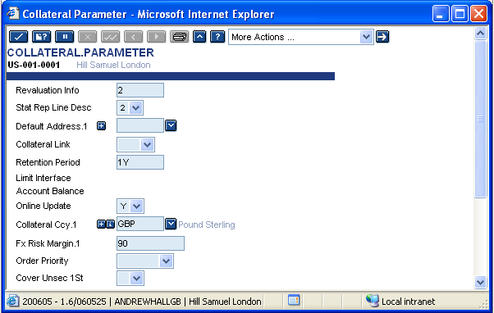

Revaluation Info: Determines to what extent a history of the revaluation of a collateral record is kept (ie. how many previous values).

Stat Rep Line Desc: Identifies which descriptive field from the report lines file is used to enrich the source & target line fields on the collateral allocation table.

Default Address. 1: Indicates types of collateral for which the address is to be defaulted from the customer record.

Collateral Link: It is a direct link from the input screen of the collateral right to the input of collateral objects belonging to it.

Retention Period: A period after the expiry date has been reached during which they remain on the 'live' file.

Fx Risk Margin: Margin for the collateral currency defined in field COLLATERAL.CCY.

Order Priority: Determines whether manual allocation of priority in COLLATERAL.RIGHT is allowed.

Cover Unsecured 1 St: The portion of a LIMIT which is allowed unsecured by collateral may be allowed before any collateral is allocated or it may be allowed after an amount covered by collateral.

Note that the DEFAULT.ADDRESS field relates to whether you want to record details from the CUSTOMER file for certain COLLATERAL.TYPE records. So you may need to amend this record again later.

There is a useful option set by the field called COLLATERAL.LINK. This takes the user to the appropriate COLLATERAL record straight after they have successfully validated the COLLATERAL.RIGHT record it relates to. Whilst this is very useful for getting the key correct and aiding input, it should be noted that the records still require authorisation in the correct order (COLLATERAL.RIGHT before related COLLATERAL records).

COLLATERAL TYPE
This file is used to define classes (or types) of COLLATERAL such as cash, buildings, guarantees and stocks (or sub-divisions thereof). The information on this file is used to determine, for each type, how the COLLATERAL value is established, re-valued and linked to other applications.
The key to this record is numeric and is entered in the COLLATERAL.CODE records.
In this example screenshot, the APPLICATION field has been set to mandatory using the APPLICATION.INPUT field and is multi-valued to allow the differing types to be accepted under this class of collateral. It should be noted that the valuation method should be valid for the types entered.
A short note on value types:
- NOMINAL.VALUE - Is the face value or current market value of collateral.
- EXECUTION.VALUE - Is expected value it would realise on sale. This can be expressed as a percentage of Nominal value if required or value of underlying MM, LD contract etc.
- THIRD.PARTY.VALUE - Shows how much value of the collateral is used outside of T24, the prior right of another lender. This amount is deducted from execution value to determine the net execution value of collateral.
- GEN.LEDGER.VALUE - The amount we record for General Ledger purposes.
- CENTRAL.BANK.VALUE - Any specific limitation on values set by the Central Bank.

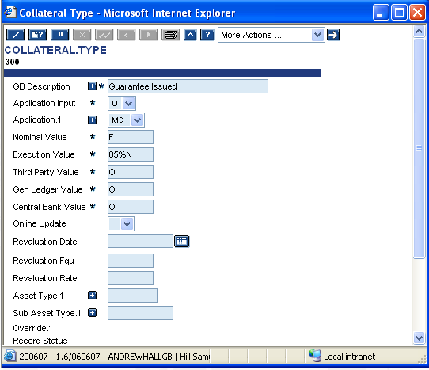
Input choices for the fields are:
- M – Mandatory
- O - Optional
- N - Non inputable
- n%N - Percentage of Nominal value
- n%E - Percentage of Execution value
- F - Fed The nominal value of the collateral is automatically fed from the application main record belonging to the collateral
- FM - Fed/Margin(available only when securities is entered in the APPLICATION field) The nominal value of the collateral is automatically fed from the application main record belonging to the collateral, using the margin value calculated by the application.
The field CASH.COLLATERAL is added to COLLATERAL.TYPE indicate whether the collateral is a cash collateral or not. 'Yes' or 'No' field. Null will be considered as No.

COLLATERAL CODE
COLLATERAL.TYPE records must be input prior to COLLATERAL.CODE record.
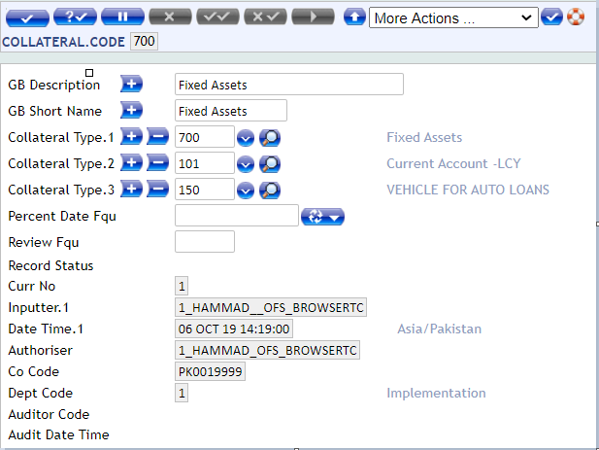
Once the values in COLLATERAL.TYPE have been input, the COLLATERAL.CODE records may be entered. The COLLATERAL.CODE allows further sub classification of the collateral objects like credit balances in account, land, buildings, bronze sculpture, stone cravings and so on. Each of these sub classifications in T24 can be recorded in a COLLATERAL.CODE record.
The collateral codes are linked to COLLATERAL.RIGHT records; these collateral rights can be recalculated and the rights themselves can also be reviewed at periodic intervals. This is achieved by using the following fields:
- PERCENT.DATE.FQU is a combined date and frequency field, which determines if and when the system is to automatically recalculate the value of the PERCENTAGE.COVER field of the COLLATERAL.RIGHT main file records belonging to this code.
- REVIEW.FQU is used to generate a default value for the REVIEW.DATE.FQU field in the COLLATERAL.RIGHT main file belonging to this code.
The collateral code is also used in determining how collateral values are reallocated across central bank reporting lines.

COLLATERAL AND LIMITS
FIXED AND VARIABLE LIMITS
When a LIMIT is linked to COLLATERAL, the LIMIT must be defined as either fixed or variable in the FIXED.VARIABLE field on the LIMIT record.
- Fixed means that the LIMIT is unaffected by the value of the COLLATERAL and the link is being made for information only.
- Variable means that the available amount of the LIMIT will correspond to the current value of the COLLATERAL.
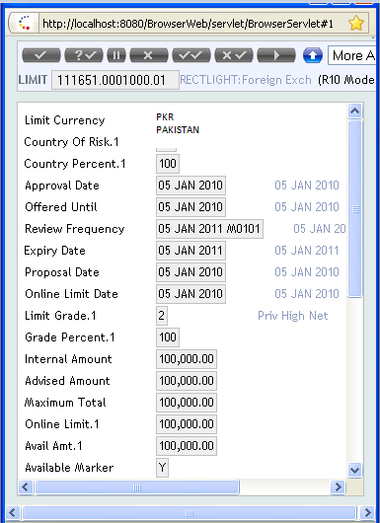

In the example above, a LIMIT is granted up to an overall maximum of GBP 100,000.00. If this facility requires security, it must be indicated by the user whether the online LIMIT is to be system-maintained (variable) or set to the full maximum total allowed and fixed at that level.
The current value of this security is, in either case, indicated by the system. In this example, there is a mortgage, currently valued at 85,000.00. In the Fixed limit the AVAIL.AMT is 100,000 however in the Variable limit the AVAIL.AMT is 85,000, which is linked to the underlying collateral. The screen shots below highlight the difference between using FIXED or VARIABLE. Notice the ONLINE.LIMT and AVAIL.AMT are different.
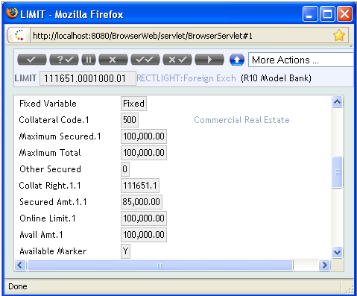

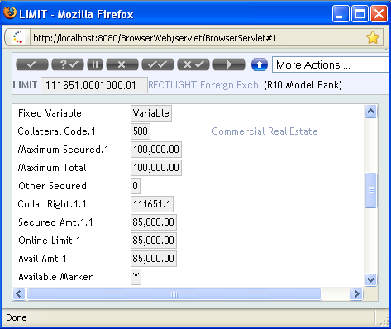

An upper limit may be set in the MAXIMUM.TOTAL field. For variable LIMIT records, this means that if the value of the COLLATERAL exceeds this maximum no, more than the MAXIMUM.TOTAL will be granted.

COLLATERAL DEAL PROCESSING OVERVIEW
Collateral records for individual customers who are offering different types of collateral to the bank need to be established. This is done using the following applications:

- COLLATERAL.RIGHT
- COLLATERAL

COLLATERAL RIGHT
The COLLATERAL.RIGHT file is used to record the status of a right of security and to indicate against which customer outstanding, the right applies. The link between the COLLATERAL.RIGHT and the COLLATERAL object itself is implicit in the item-id structure between the two files.
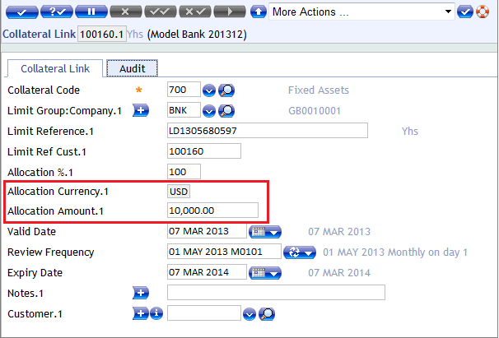

Field ALLOCATION.AMT is used to specify allocation amount. This is allowed only when the Contract Reference is directly provided. Field ALLOCATION.CCY is defaulted by system based on the contract id.
The LIMIT.REFERENCE field on the COLLATERAL.RIGHT record is used to identify which contract(s) the collateral is valid against. This link between the collateral and the outstanding debit balances belonging to the customer may be made at one of three levels as follows:
- Contract/account level - the collateral is valid only against a given contract or set of contracts
- Limit level - the collateral is valid against all contracts currently recorded under a particular limit reference and against any contracts which subsequently come under the limit
- Customer level - the collateral is valid against any debit balance, which exists or arises on the customer’s accounts or contracts with the bank.

LIMIT LEVEL
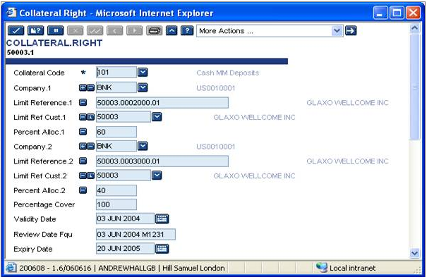
The COLLATERAL is valid against all contracts currently recorded under a particular limit reference and against any contracts, which subsequently come under that LIMIT.
Collateral can be allocated to limits at any product level if PERCENT.ALLOC is populated; in this case, the percentage of the execution value of the COLLATERAL defined is directly allocated to the limit defined in LIMIT.REFERENCE.
If PERCENT.ALLOC is not defined then the execution value of the defined collateral is allocated in order of entry, to the limit at the top of the limit structure of the limit defined in LIMIT.REFERENCE. The amount allocated is for the value of the ONLINE.LIMIT until the execution value of the collateral is exhausted.

CUSTOMER LEVEL
The COLLATERAL is valid against any debit balance, which exists or arises on the customer's accounts or contracts with the bank.
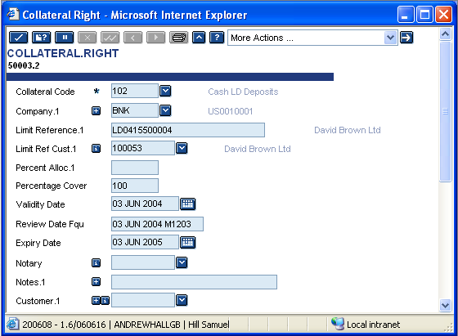

It is important to note that though the default name of the field is LIMIT.REFERENCE, the actual content may be either:
- An ACCOUNT
- A FOREX contract
- A MM.MONEY.MARKET contract
- A MG.MORTGAGE contract
- An MD.DEAL contract (Guarantee)
- A valid LETTER.OF.CREDIT
- An AA Loan Arrangement
- Or the entire CUSTOMER outstanding's if this is left blank

COLLATERAL
The item of collateral itself is defined on the COLLATERAL file, which contains details of the values, review frequency, value date and expiry of the collateral.
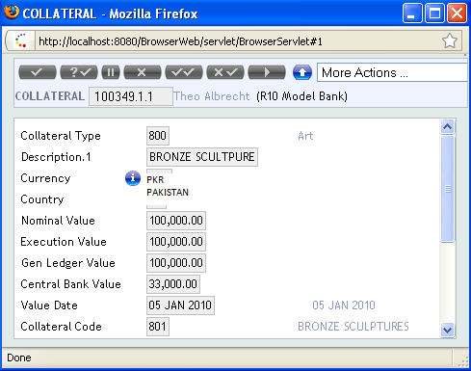
It is also possible to define a partial use of an item, a fixed amount of the available collateral and even on the contract itself a maximum usage of that collateral. At present this is restricted to Money market deposits.
There is the option to enter an EXPIRY.DATE on both the COLLATERAL item itself and the controlling COLLATERAL.RIGHT. An item of COLLATERAL is marked as liquidated on the earlier of these two dates. Once the COLLATERAL expiry is reached, the value is no longer useable by the system, whereas when the COLLATERAL.RIGHT expiry is reached, the right to all collateral linked to it becomes invalid.
Note: The expiry of the item of collateral (such as the deposit contract maturity) is not defaulted automatically to the EXPIRY.DATE field. This is because the underlying contract can of course be extended at any time.
A collateral can be excluded from the surplus or deficit calculation of the customer’s assets and in the liability allocation.

Assumptions & Exclusions
- Any integration / alignment of their existing system are neither covered, nor is part of our future development via this FSD.
- Since this is a Greenfield deployment, all the existing COB reports which are present in the system will be available. TBI has not requested any reports or enquiries therein.

Reporting (Enquires and COB Reports)
Standard reports and Inquires will be made available as mentioned above in workflow. However, apart from the standard reports/inquiries, if TBI require any further reports (other than Regulatory), will be handled through change management.

